# Allowing Ping through the Windows 10 Firewall

The default firewall setting allows ping through the firewall, but only if the computer is in a domain network. Since our computers are not in a domain, we need to allow ping for Private and Public networks.

Type *control* in the search window, and open the Windows control panel. 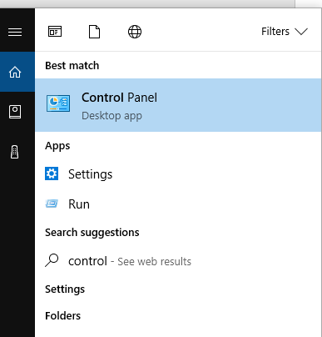

Open the Windows Firewall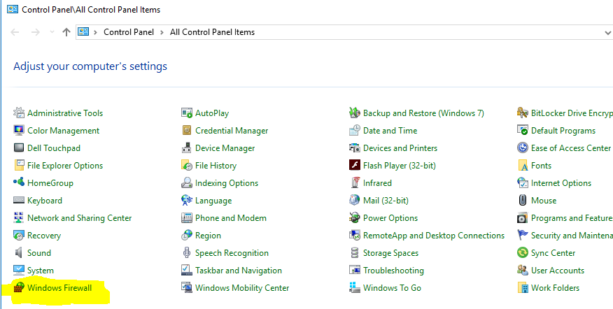

Click on Advanced settings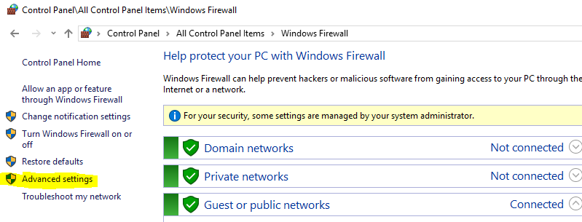

Or, you can skip all the clicking by opening an elevated command prompt and typing *wf.msc*

In the Windows Firewall control panel, search for the line that allows “File and Printer Sharing (Echo Request-ICMPv4-in). Note that there are two lines, one for the Domain Profile (already enabled) and one for the Private, Public Profiles (not enabled.) We need to enable the one that is not enabled.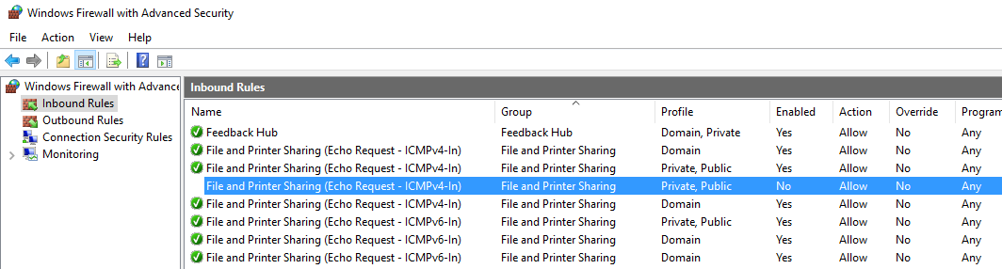

Change the setting for the Private, Public rule to enabled. 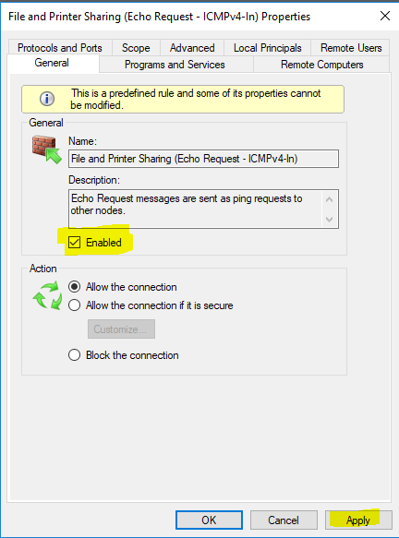

Or, from an elevated PowerShell prompt:

PS C:\WINDOWS\system32> enable-netfirewallrule -name fps-icmp4-erq-in